**API calls using Postman**

Setup Postman to get Auth token from Cognito User

User credentials are in **cognito.tf**

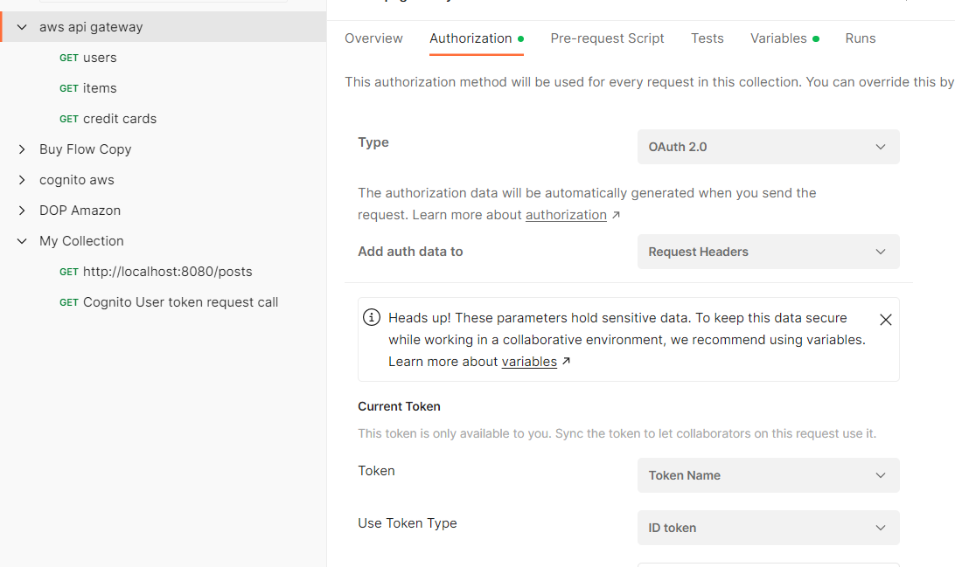

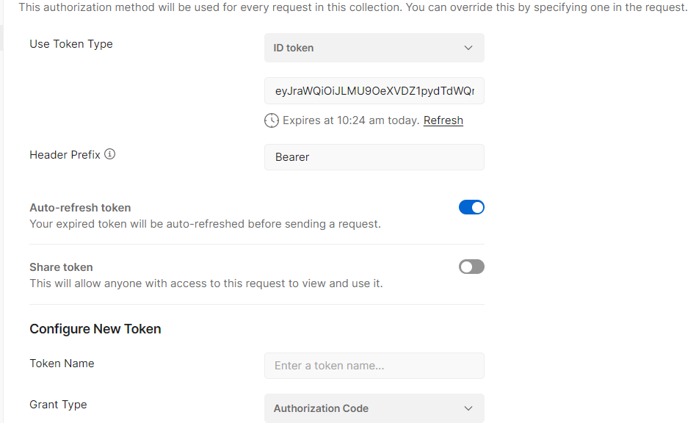

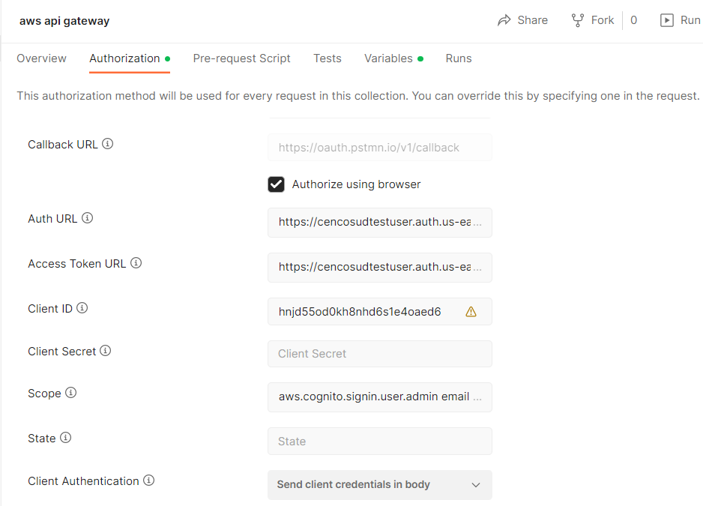

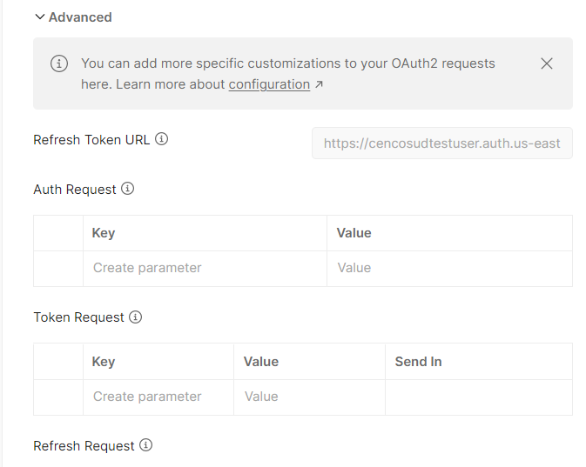

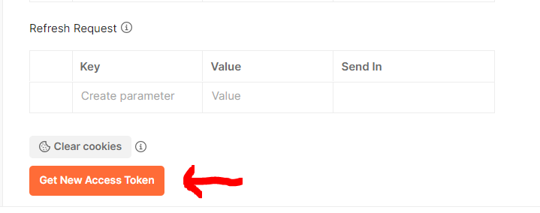

Below responses are retrieved from Redshift database. Script to insert data is under **docs ->redshift_sql ->init.sql**

{{url}} is saved as environment variable –

**https://6q2bwtrgnd.execute-api.us-east-1.amazonaws.com/DEV**

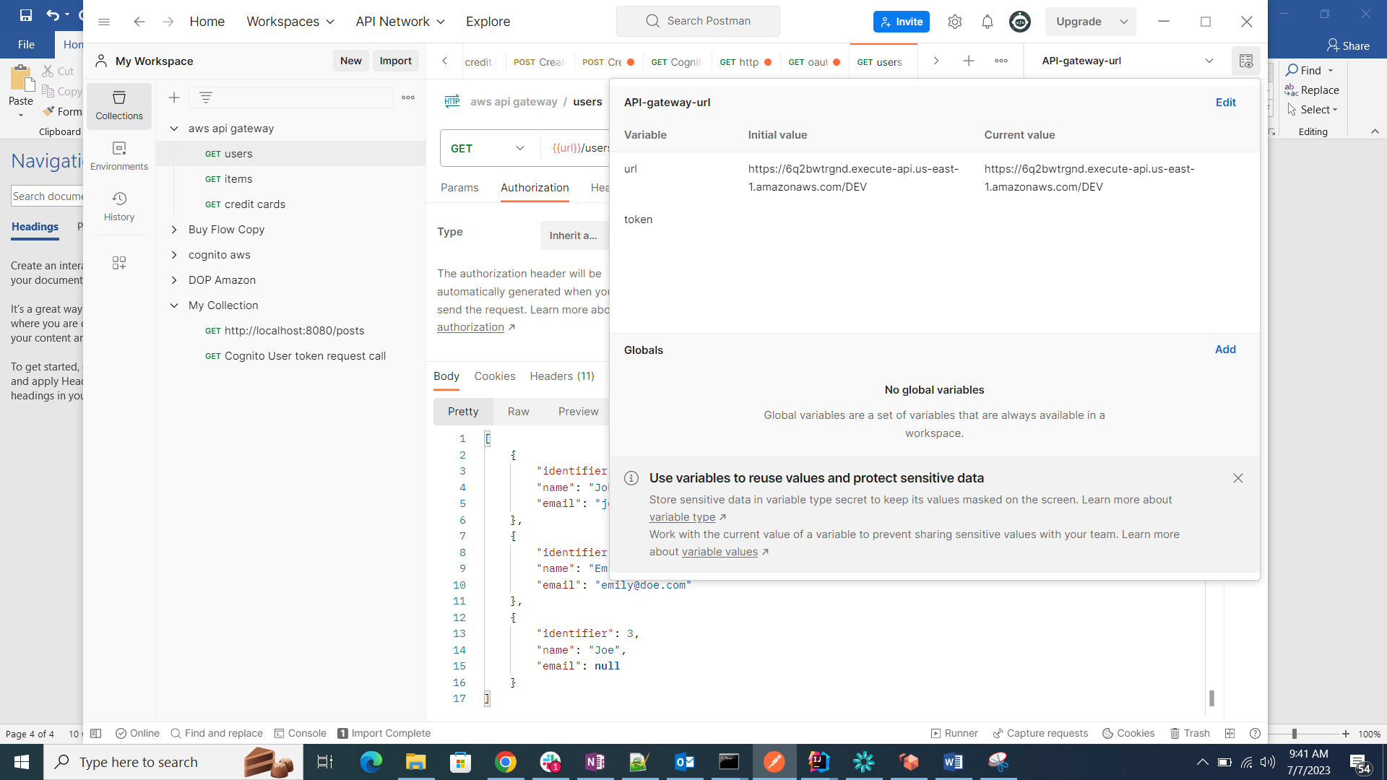

**GET /users**

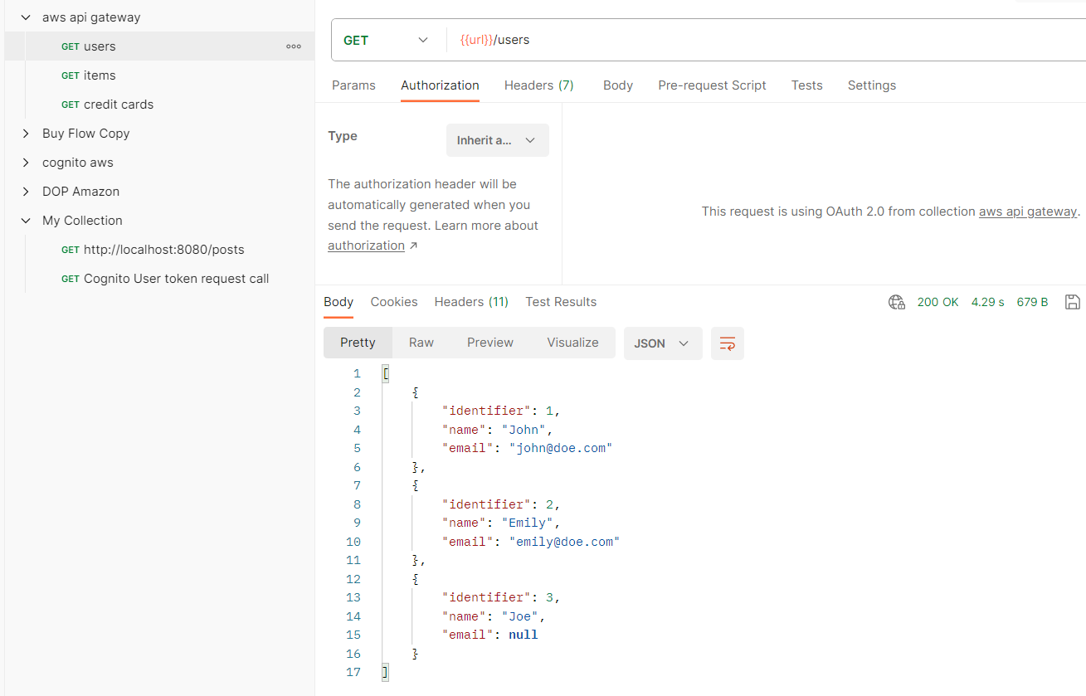

**GET /items**

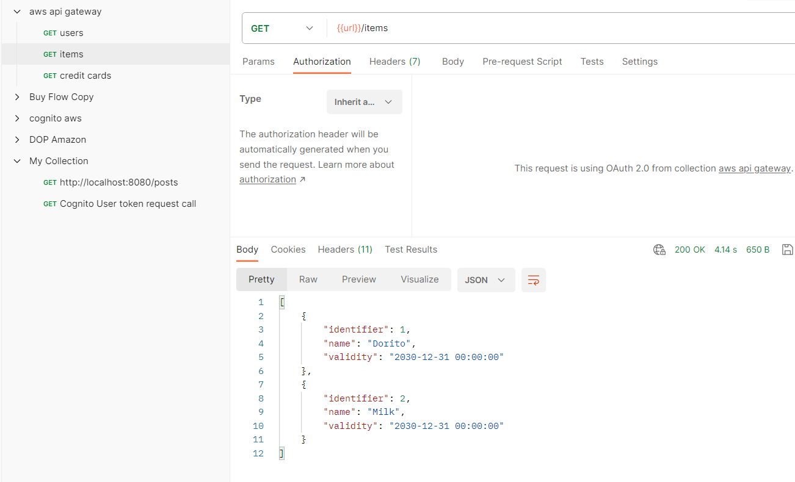

**GET /credit_cards**

